Cloud Computing Overview

The termCloudrefers to aNetworkorInternet. In other words, we can say that Cloud is something, which is present at remote location. Cloud can provide services over public and private networks, i.e., WAN, LAN or VPN.

What is Cloud?

What is Cloud Computing?
Cloud Computingrefers tomanipulating, configuring,andaccessingthe hardware and software resources remotely.

Basic Concepts
Deployment Models
- Service Models
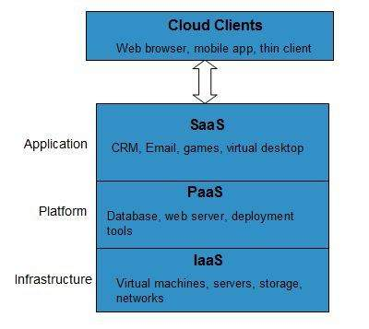

History of Cloud Computing
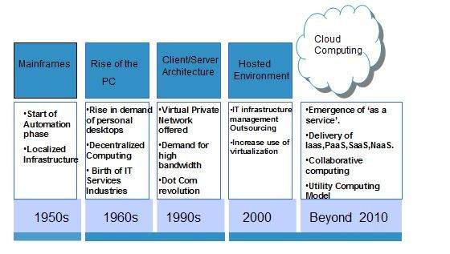
https://www.geeksforgeeks.org/cloud-computing/history-of-cloud-computing/

Evolution of Cloud Computing
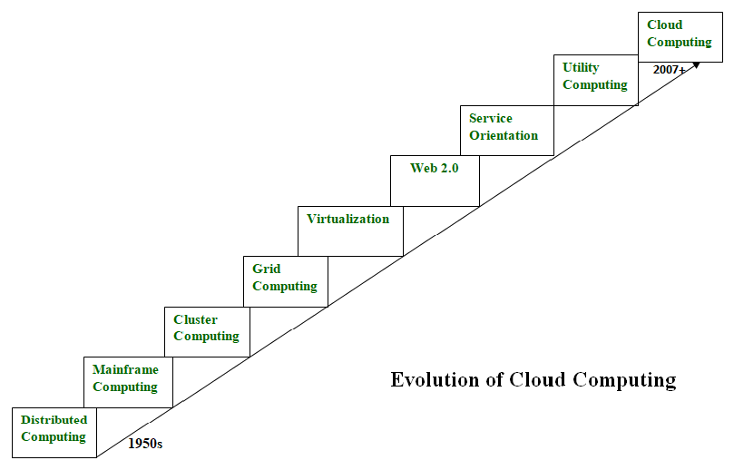

Benefits

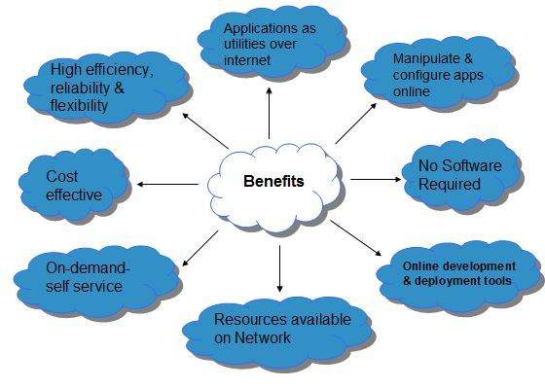

Risks related to Cloud Computing

Characteristics of Cloud Computing
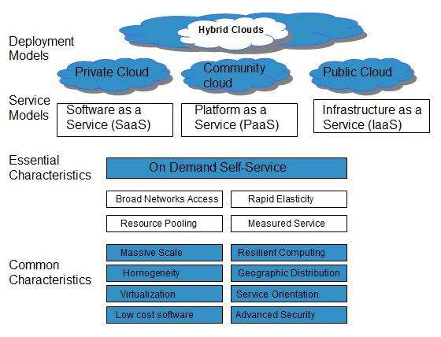

What is Cloud Computing?
some examples of cloud computing are −
- Dropbox − It is a one-stop solution for all the services like file storage, sharing, and managing the system.
- Microsoft Azure − It provides a wide range of services like the backup of data and any sudden recovery from any type of disaster.

Evolution of Cloud Computing

1. Distributed Systems
- Mainframe Computing
- Cluster Computing
- Grid Computing

2. Web 2.0
This computing lets the users generate their content and collaborate with other people or share the information using social media, for example, Facebook, Twitter, and Orkut. Web 2.0 is a combination of the second-generation technology World Wide Web (WWW) along with the web services and it is the computing type that is used today.

3. Virtualization
It came into existence 40 years back and it is becoming the current technique used in IT firms. It employs a software layer over the hardware and using this it provides the customer with cloud-based services.

4. Utility Computing
Based on the need of the user, utility computing can be used. It provides the users, company, clients or based on the business need the data storage can be taken for rent and used.

Characteristics of Cloud Computing

On-Demand Self-Service

Broad Network Access

Scalability or Rapid Elasticity

Security

Automation

Budget Friendly

Flexibility

Cloud Computing Planning
Before deploying applications to cloud, it is necessary to consider your business requirements. Following are the issues one must consider:
- Data Security and Privacy Requirement
- Budget Requirements
- Type of cloud - public, private or hybrid
- Data backup requirements
- Training requirements
- Dashboard and reporting requirements
- Client access requirements
- Data export requirements

Cloud Computing Architecture
Cloud Computing architecture comprises of many cloud components, which are loosely coupled. We can broadly divide the cloud architecture into two parts:
- Front End
- Back End
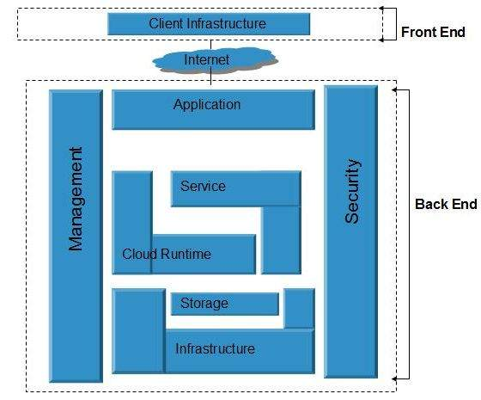
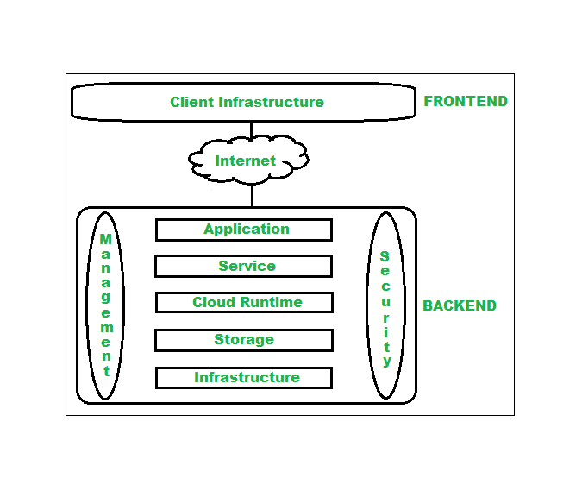

Cloud Computing Architecture Example
The following applications uses cloud computing architecture :

1. Online Learning App (techsha Classroom)
Students are using techsha application for watching tutorials for learning purpose, they solve different coding problems and take quizzes also for testing their skills. They can use this anywhere by using their mobile phones, tablets or personal laptop. For storing videos and study materials Geeksforgeeks are using cloud services like Amazon S3. It also uses AWS Lambda to run small backend tasks like checking quiz answers or updating progress. For managing users and logins securely, services like AWS IAM (Identity and Access Management) are used. All of this helps the application work smoothly, keeps your data safe, and makes sure your learning experience is always available and fast.

2. Online Store (E-Commerce Website)
Everyone is using online websites like Amazon or Flipkart for online shopping. It uses cloud computing to run its website and manage orders. When you browse and buy products, you’re using the front end. In the background, cloud services keep track of what’s in your cart, handle payments, and update stock. Developers use platforms like AWS Elastic Beanstalk to run the website easily. The product photos are saved in cloud storage like Amazon S3, and customer details are stored in databases. Cloud tools also watch over the site to keep it secure and running fast.

3. Mobile App Backend (Food Delivery App)
Think of a food delivery app like Zomato or Swiggy. You use the app to order food, and everything works smoothly just because of cloud computing. The app you see on your phone is the front layer. When you order something, cloud services handle the process in the background like telling the restaurant, tracking your order, and handling payments. Platforms like Firebase help with storing user info and sending notifications. The servers that run the app live in cloud data centers like Google Cloud or AWS, and all your data is kept safe using secure login systems.

Cloud Computing Infrastructure
Cloud infrastructureconsists of servers, storage devices, network, cloud management software, deployment software, and platform virtualization.
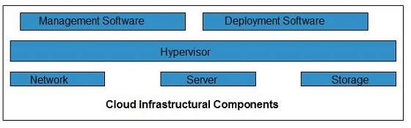
Still cloud infrastructure is categorized into three parts in general i.e.
- Computing
- Networking
- Storage

What is Cloud Storage?
Cloud storage is a method to save data on the internet instead of your computer or hard drive. It allows you to store files (like documents, images, videos, backups, and more) on remote servers that are managed by cloud service providers. You can access your files anytime and from anywhere using the internet. When we upload a file to a cloud-based server like Google Drive, OneDrive, or iCloud, that file gets copied over the Internet into a data server that is cloud-based actual physical space where companies store files on multiple hard drives. Most companies have hundreds of these servers known as 'server farms' spanning across multiple locations.

- Storage Types:
  - Object Storage: Best for unstructured data like media files, backups, or logs (think Amazon S3 or Google Cloud Storage).
  - Block Storage: This is faster and used for applications like databases (e.g., Amazon EBS, Azure Disk Storage).
  - File Storage: Works like a shared drive and is great for file hierarchies (e.g., Amazon EFS, Azure Files).
- Metadata: Keeps track of information about the data—like file names, sizes, and access rules.

Addressing Common Concerns about Cloud Computing

1. Security

2. Data Privacy

Top Leading Cloud Computing Companies
The following tables show the top leading cloud computing companies along with key details about their cloud services:
Company | Cloud Service Name | Key Offerings
1. Amazon | AWS (Amazon Web Services) | Compute, Storage, AI/ML, Databases, Networking
2. Microsoft | Azure | Cloud computing, AI, Analytics, Hybrid Cloud
3. Google | Google Cloud Platform (GCP) | AI/ML, Big Data, Kubernetes, Cloud Storage
4. Alibaba | Alibaba Cloud | IaaS, AI, Big Data, Cloud Security, CDN
5. Oracle | Oracle Cloud | Enterprise Cloud, Databases, SaaS, PaaS
6. IBM | IBM Cloud | AI, Quantum Computing, Hybrid Cloud, Security
7. Salesforce | Salesforce Cloud | CRM, SaaS, AI, Analytics
8. Tencent | Tencent Cloud | AI, Gaming Cloud, IoT, Big Data

https://www.tutorialspoint.com/cloud_computing/cloud_computing_infrastructure.htm
https://www.geeksforgeeks.org/dbms/real-world-applications-of-cloud-computing/

